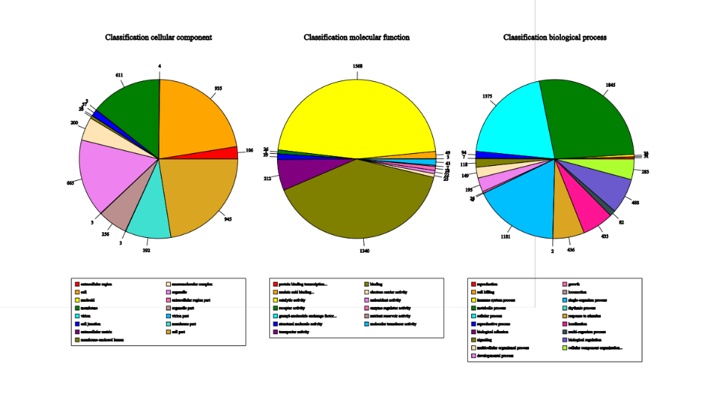
Figure S1. GO Analysis of DEGs between control (CK) and low nitrogen (LN) treatments

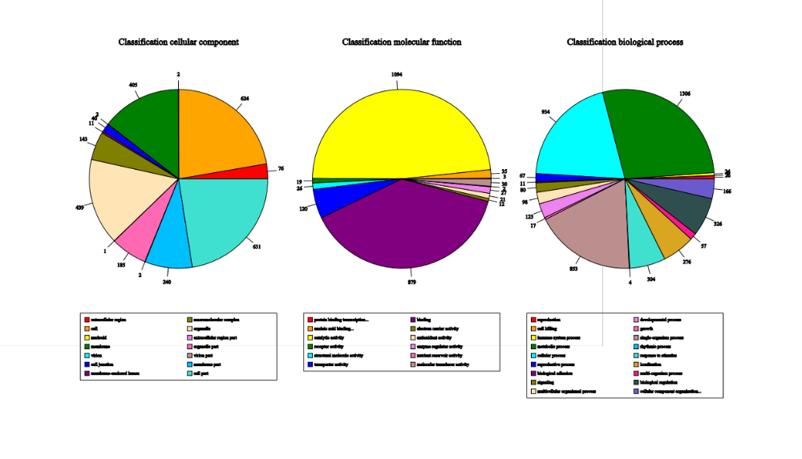
Figure S2. GO Analysis of DEGs between high nitrogen (HN) and control (CK) treatments

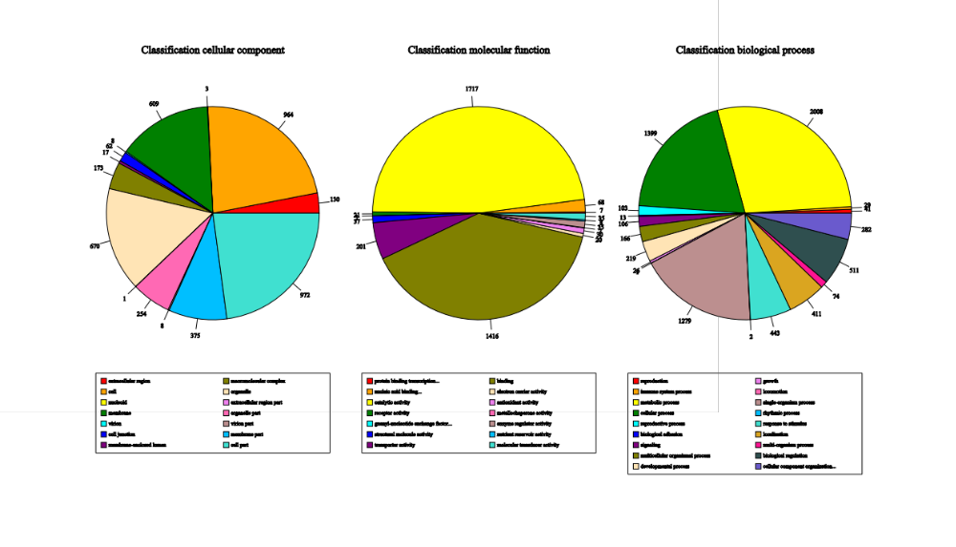
Figure S3. GO Analysis of DEGs between low nitrogen (LN) and LN + NPA treatments

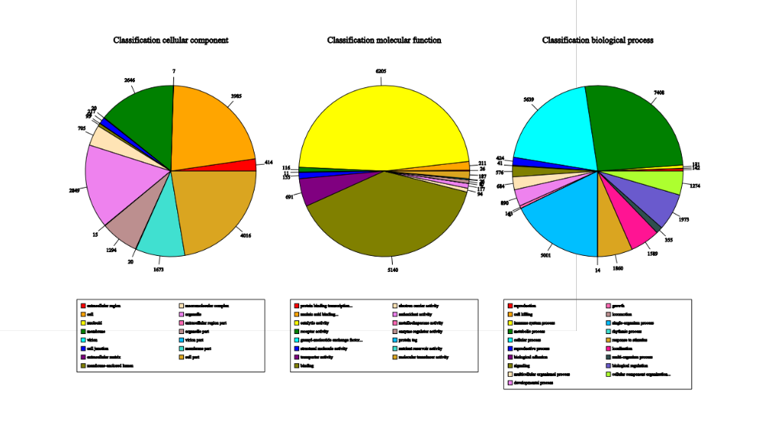
Figure S4. GO Analysis of DEGs between high nitrogen (HN) and HN + IBA treatments

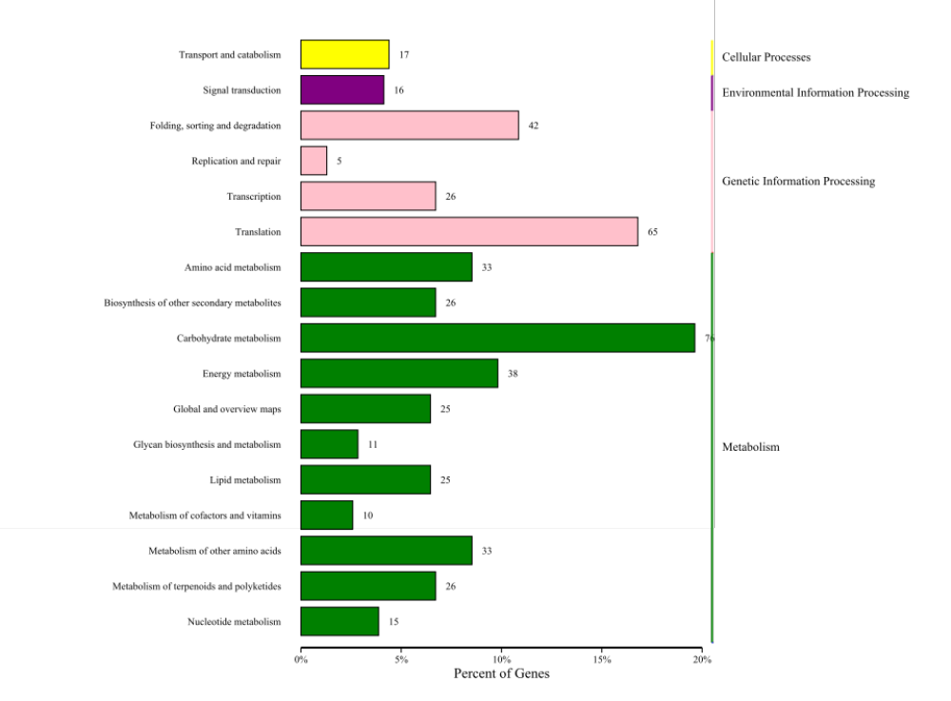

Figure S5. KEGG Analysis of DEGs between control (CK) and low nitrogen (LN) treatments

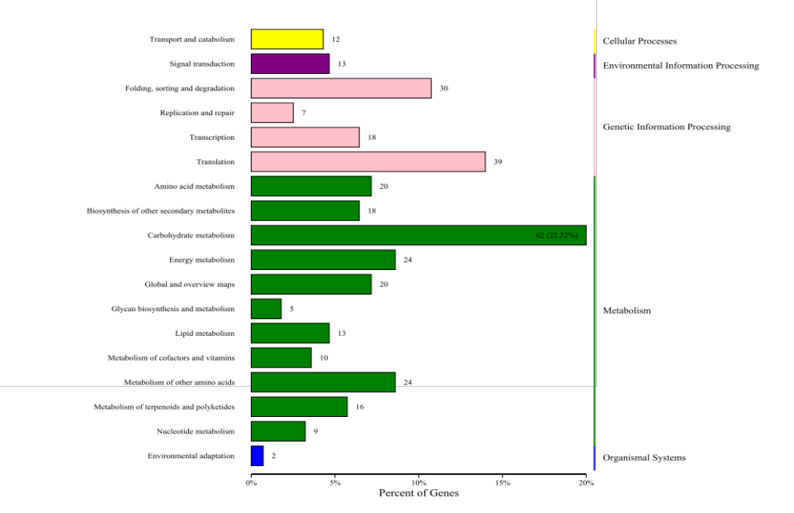
Figure S6. KEGG Analysis of DEGs between high nitrogen (HN) and control (CK) treatments
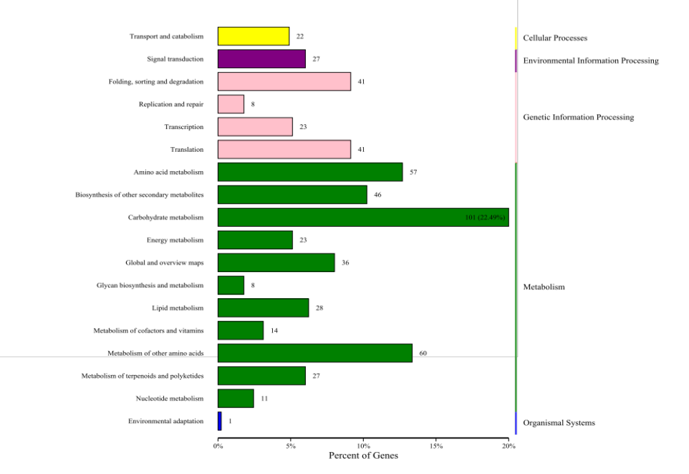
Figure S7. KEGG Analysis of DEGs between low nitrogen (LN) and LN + NPA treatments

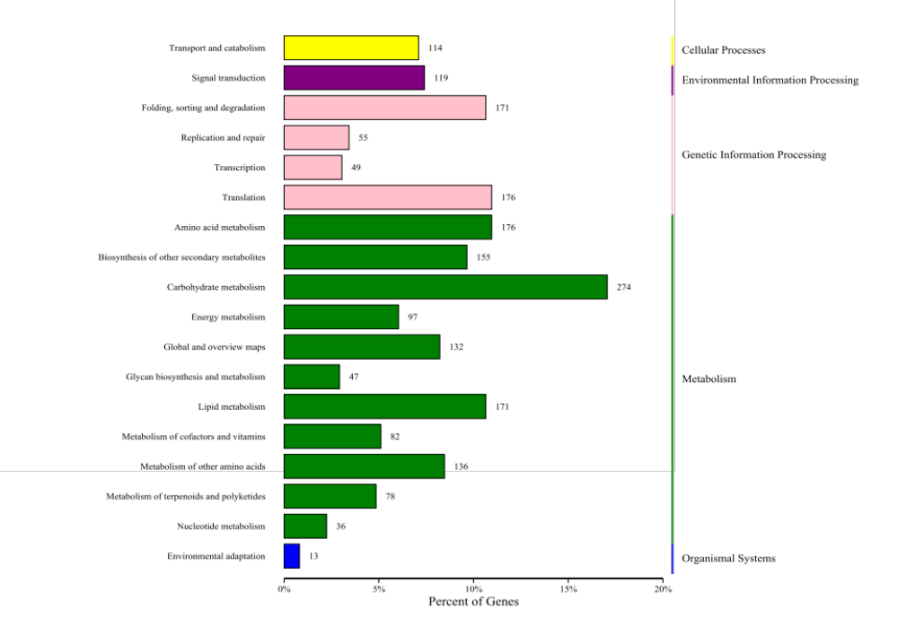
Figure S8. KEGG Analysis of DEGs between high nitrogen (HN) and HN + IBA treatments

